“GSTN removes E-Way Bill requirement for select goods.”

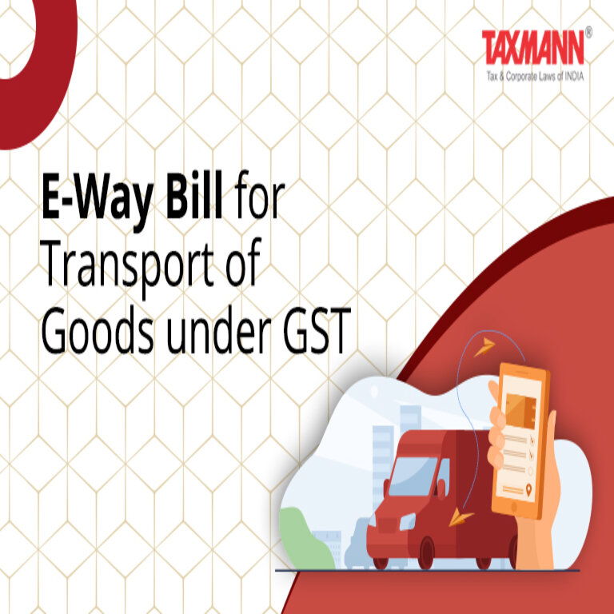

Clarification on E-Way Bill Requirement for Goods under Chapter 71
Rule 138(14) of the Central Goods and Services Tax (CGST) Rules, 2017, read with its Annexure S.Nos. 4 and 5, states that goods covered under Chapter 71 viz., Natural or cultured pearls and precious or semi-precious stones; precious metals and metals clad with precious metal, Jewellery, goldsmiths’, and silversmiths’ articles, except those classified under HSN 7117 (Imitation Jewellery), are exempt from the mandatory requirement of generating an E-Way Bill.
Pursuant to the introduction of the E-Way Bill (EWB) for goods classified under Chapter 71, excluding HSN 7117 (Imitation Jewellery), in the state of Kerala for intra-state movement, the National Informatics Centre (NIC) has provided an option to generate EWBs for goods covered under Chapter 71 except 7117 under the category “EWB for Gold” on the EWB portal.
It has been observed that various industry stakeholders have voluntarily been generating EWBs for goods under Chapter 71 due to the availability of this option in the EWB system. In this regard, it is clarified that while the system previously allowed EWB generation for goods under Chapter 71, this facility has now been withdrawn.
Accordingly, taxpayers and transporters engaged in the movement of goods under Chapter 71 (except HSN 7117) are advised that EWB generation is not required. However, it may be noted that for the intrastate movement of such goods within the state of Kerala, the generation of an EWB has been mandated vide Notification No.10/24-State Tax dated 27/12/24 issued by the state of Kerala. An advisory dated 27.01.2025 has already been issued in this regard.
Industry stakeholders are requested to take note of this clarification and ensure compliance with the applicable regulatory provisions.

Highlights of the Advisory on E-Way Bill for Chapter 71 Goods

Particulars | Details
Applicable Goods | Natural/cultured pearls, precious/semi-precious stones, precious metals, jewellery, goldsmiths’ and silversmiths’ articles (excluding HSN 7117 – Imitation Jewellery)
Previous System | Option to generate E-Way Bills (EWB) for Chapter 71 goods was available on the EWB portal under “EWB for Gold”
Change Implemented | The facility to generate EWBs for Chapter 71 goods (except HSN 7117) has been withdrawn
Current Requirement | No EWB required for goods under Chapter 71 (except in Kerala)
Special Case – Kerala | Kerala has mandated EWB for intra-state movement of Chapter 71 goods (except HSN 7117) via Notification No. 10/24-State Tax dated 27/12/24
Industry Advisory | Businesses must ensure compliance with these changes and stop generating EWBs for Chapter 71 goods unless required in Kerala
Where to Seek Clarifications? | GST Helpdesk or jurisdictional tax authorities

Impact of This Advisory
- Relief for Businesses Nationwide – No need to generate EWB for Chapter 71goods, reducing compliance burden.
- Exception for Kerala – Businesses in Kerala must comply with local requirements and generate EWB for intra-state movement.
- Prevention of Unnecessary Compliance – The system no longer allows voluntary EWB generation for these goods, preventing confusion.
Conclusion: Businesses dealing with jewellery, precious stones, and metals should ensure compliance with this update. EWB is not required for these goods except in Kerala, where state-specific rules apply. Stakeholders must take note of the changes and follow the correct procedures to avoid any penalties or non-compliance issues.

